Graphics and Animation Tools
LAB
Experiment – 2 Design of Logo using GIMP.

Step – 1:

Open GIMP, go to file → new file → choose 1920x1920 size screen with white as background.
And select the fill with transparency.

Step – 2:

Go to image → guide → guide by percent → (horizontal & vertically 50 percent) → OK

Step – 3:

Go to View → Enable Snap to Guide and Snap to Canvas edges.

Step – 4:

Grab the ellipse select tool, start creating a circle at the center and hold ctrl+shift to create an image covering whole canvas (which creates perfect symmetrical circle.)
Press enter, Go to Edit → fill with background color (white) → Go to Select → NONE.

Step – 5:

Create new layer (with transparency selected) Repeat the step 4 to create a bit smaller circle (black).

Step – 6:

Create new layer, create a new circle quite close to previous one and then (after swapping the FG and BG color)
Go to Edit → Stroke selection → Solid color ( anti-aliasing turned on and Line width 25) → OK → Select → NONE.
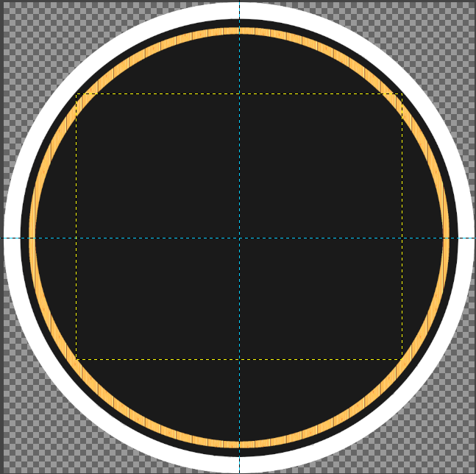

Step – 7:

Create New Layer → grab the Rectangle select tool → Create Rectangle on the top of the circle. → edit → fill with BG color. → select none → Layer → auto crop layer (to make layer of the same size as the object.)

Step – 8:

Create a rectangle on (quarter of ) new layer (filled with the FG color). Select NONE. Bring the rectangle to center of page, rotate till the white triangle on the black box ifs formed. (Auto crop this layer too). Scale it to your compatibility. On this layer Right click and select (Alpha to Selection). → Delete → Select None.

Step – 9:

Create Duplicate of the Small Rectangle layer, go to edit and fill with the Foreground Color(White). Select → none → Layer → Layer to Image Size.

Step – 10:

Now Grab scaling tool, turn down opacity, scale it up, Now Bring down the scaled Layer down of the Smaller one, and bring the opacity up again. Now Select the brush tool, Select a default Star Brush and click on the Center (After Creating a new layer)

Step – 11:

Merge all the Layers used to create the Rectangle, and create a Duplicate of that Layer and Flip it Vertical (sing the flip tool)

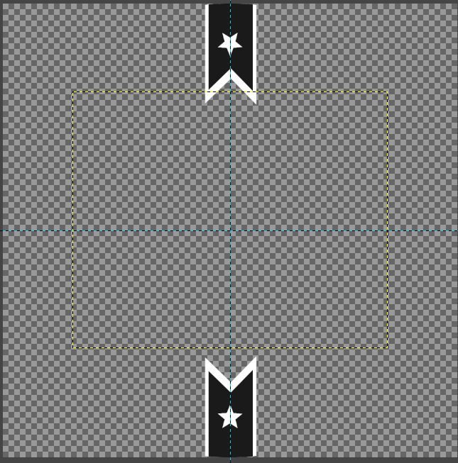

Step – 12:

Now to cut the extra area coming out of the Circle, Click on the background layer → Alpha to selection → Select → Invert → Click on the Extra layer → delete → Select NONE

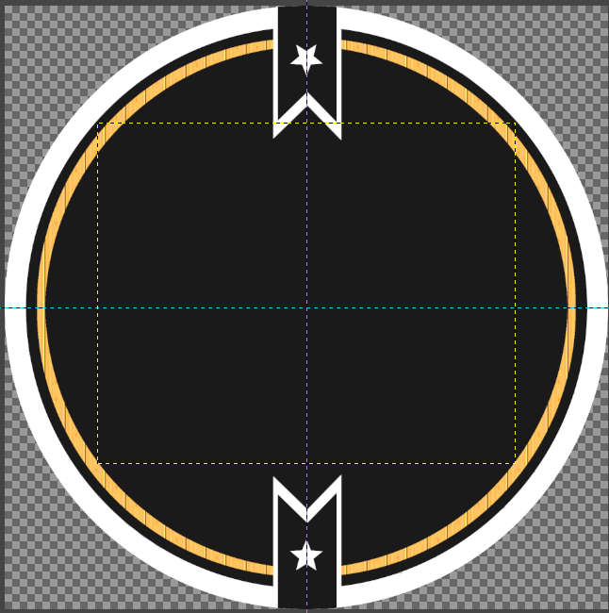

Step – 13:

Now select the Text tool (Write your Own Text)

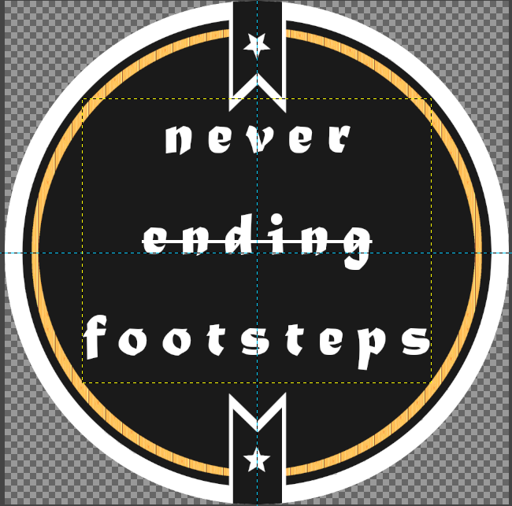
Specifications for my text:- Font (Matura MT Script Capitals) & Size (60).

Step – 14:

Select Save AS → your file name.xcf (to save as a gimp file.)
Select Export → your gile name.jpg(to save as an image file.)

